

**KABARAK UNIVERSITY**

**SCHOOL OF SCIENCE, ENGINEERING AND TECHNOLOGY**

**DEPARTMENT OF COMPUTER SCIENCE**

**SOFTWARE PROJECT**

**TEAM PROJECT TITLE: CLASS ALLOCATION SYSTEM.**

***This research is submitted to Kabarak University School of Science, Engineering and Technology in partial fulfilment of the degree of Computer Science***

**SUBMITTED BY**

**MULI ANN**

**CS/MG/1965/05/18**

**NGERECHI CHEROTICH MERCY**

**CS/MG/2743/09/18**

**SUPERVISOR: Mr. Martin Kimutai**

# **DECLARATION AND APPROVAL**

**Student’s Approval.**

The work contained in thisproject document entitled “CLASS ALLOCATION SYSTEM” SUBMITTED TO THE Department of Computer Science, Kabarak University is a record of original work to the best of our knowledge that has not been previously documented in any other higher education institutions.

NAME: MULI ANN

REG NO: CS/MG/1965/05/18

Signature………………………

NAME: NGERECHI CHEROTICH MERCY.

REG NO: CS/MG/2743/09/18

Signature………………………

**Supervisor Approval**

This proposal has been submitted to Kabarak University for review with our approval for Examination to the University supervisor.

Name:

Date:

Sign:

# ACKNOWLEDGEMENT

We would like acknowledge the Almighty God whom has enabled us to be alive and healthy and through His Grace and Mercies we have made it this far in the pursuit of our academic studies through the years.

This project itself is an acknowledgement to the inspiration, drive and technical assistance of many individuals. We express our gratitude to our project supervisor Mr. Martin Kimutai for his continuous scholarly guidance and encouragement throughout the project and the Kabarak University management for providing us with an enabling environment and excellent infrastructure to lay a strong foundation for our professional lives. Moreover, we acknowledge and dedicate this work to our families for their emotional, financial and spiritual support, may they be blessed abundantly.We would also like to express our gratitude to our fellow students who participated in the data collection process with their valuable feedback forming a basis in the foundation of our research study.

# 

# ABSTRACT

KABU-CAS is a system application proposal designed to assist the timetabling office, lecturers and class representatives of different schools to allocate classes within the schools through an online based web application. The system is designed to address the challenges faced by the students and lecturers looking for rooms for their makeup classes or those that have rescheduled their classes due to the increased number of student’s in different schools. It also notifies the lecturers of their upcoming classes in advance for them to prepare. The study aims to develop a website that enables class representatives and lecturers of Kabarak University to access information about the vacant classes of different schools at different periods easily thus saving time.

Table of Contents

**DECLARATION AND APPROVAL** 2

ACKNOWLEDGEMENT 3

ABSTRACT 4

CHAPTER 1: Introduction. 7

1.1 Background Study 7

1.2 Statement of the problem 8

1.3 Objective of the Study 8

1.4 Justification of the Problem. 8

1.5 Significance of the Problem 8

1.6 Scope of the Study 9

1.7 Limitations 9

CHAPTER 2: Literature Review 10

2.1 Introduction 10

2.2 General Overview of the literature related to the main concept 10

2.3 Review based on objective one 10

Chapter 3: Methodology 11

3.1 Introduction 11

3.2 Research Design methods 11

3.3 Location of the Study 11

3.4 Population of the Study 11

3.5 Sampling Procedure 11

3.6 Data Collection Procedure 11

CHAPTER 4 12

**4.0 SYSTEM ANALYSIS AND DESIGN** 12

4.1 Functional requirements 12

4.2 Non-functional requirements 12

4.3 CONTEXT DIAGRAM 12

4.4 USE-CASE DIAGRAM 13

13

4.6 Software Tools 14

CHAPTER 5 15

5.0 DISCUSSIONS. 15

CHAPTER 6 21

6.0 RECOMMENDATION 21

6.1 CONCLUSION 21

REFERENCES 21

APPENDIX 22

Figure 1 7

Figure 2 12

Figure 3 13

Figure 4 15

Figure 5 16

Figure 6 17

Figure 7 17

Figure 8 18

Figure 9 18

Figure 10 19

Figure 11 19

Figure 12 20

# CHAPTER 1: Introduction.

# Background Study

In the beginning of every semester, the timetabling office designs a one timetable for each school. These timetables are usually complex in a way since different units for different semesters are usually placed in one timetable for each school giving the class representatives the work of simplifying the timetables, contacting different lecturers about their classes and for a specific class if any changes have to be done like change the time or allocation of a class, the class representative has to manually look for the vacant rooms at the most preferred time. The class representatives therefore have to contact the lecturer back and notify them of the possible classes available at different times. Most of the times, a lot of time is wasted during class period of the first few weeks of the semester since the students have to look for classes during that time.

Below is a sample timetable provided by the timetabling office.

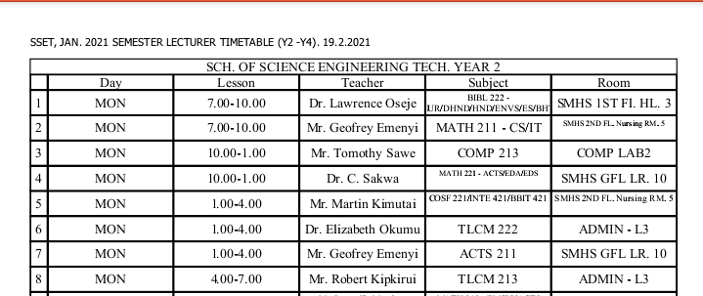

Figure 1

The timetabling method used has been used for the past several years and it was most effective during the years when there was a controllable number of students in the school but now that there is a huge growth of the student’s population due to the enrollment of government sponsored students, the timetabling method has not been effective. Sometimes the classes allocated might be small since a lecturer can decide to merge two classes taking similar units. In the classes where electronic devices like laptops are needed, that class has to look for a lap which has charging ports.

# Statement of the problem

In Kabarak University, due to increased growth of the number of students in different schools, there has been the issue of time wastage during class period when the students are manually looking for location of either rescheduled or make up classes.

# Objective of the Study

The main objective of this study is to develop an online system that helps in allocation of lecture halls.

The system will focus on the following objectives:

1. To examine a system that will enable accurate and easy allocation of lecture halls.
2. To develop the proposed system that help save on time.
3. To identify challenges faced by class representatives when they are looking for rooms for their units.
4. To evaluate the proposed system.

# 1.4 Justification of the Problem.

KABU-CAS website will be able to offer several benefits. These benefits include:

1. Providing a platform that has a simplified version of the timetable.
2. Easy allocation of make-up and rescheduled classes
3. Save time when looking for vacant classes.
4. Reduces the probability of double booking a class.

# Significance of the Problem

The significance of the problem is that class allocation will be more accurate using the Class Allocation System.

This research study is significant in discovering and addressing some of the perennial problems faced by students and class representatives in academic institutions contributing to the general body of knowledge forming a basis for further future research in other institutions. It will also help academic institutions in seeking better ways of further improving their quality of service by addressing the challenges faced.

# Scope of the Study

The goal of our study is to simplify the timetables provided by the timetabling office, save on time when looking for make up classes and also sends a reminder to the lecturers before their period begins.

# Limitations

1. The system will only work when there is availability of internet since it’s web based.

# CHAPTER 2: Literature Review

## 2.1 Introduction

Manual timetabling is most commonly used in universities for allocation of courses and lecture halls. Manual timetabling is cheap, readily available and easy to read and interpret. Lecture halls allocated using this manual system guides students in where they are supposed to study for their various courses. Manual timetables enable students and tutors to know the day and time they are supposed to study a particular course, the lecture hall and also their lecturer. When interpreting the students and tutors will look for a specific course in the timetable. However, manual timetabling is inaccurate and in many cases a course will be unallocated or it will be allocated a lecture hall already assigned. Coming up with a class allocation system helps improve accuracy. As for manual timetabling, however, accurate allocation of courses is extremely challenging and tiresome due to the fact that a lot of people need to be involved. Lecture halls need to be accurately allocated to ensure smooth running of the university. Automatic class allocation is an important and challenging task.

## 2.2 General Overview of the literature related to the main concept

There have been numerous attempts on manual timetabling to allocate lecture halls. This process involves receiving courses from the various heads of department and allocating them lecture halls. Class Allocation System used by the University of Western Australia is one example.

**CLASS ALLOCATION SYSTEM USED BY THE UNIVERSITY OF WESTERN AUSTRALIA:** [**https://www.cas.uwa.edu.**](https://www.cas.uwa.edu.)

The paper focuses on allowing students enrolled in most units to enter their preferences for available lectures, tutorials, labs and other activities. Once entered, the Class Allocation System allocates students to classes based on their preferences, and then enables students to review and adjust their allocations if required. The intention is to provide students with their allocated timetable 3-4 weeks prior to the start of semester in order to help students align their scholastic, work and social commitments.

## Review based on objective one

Class Allocation is usually done manually, whereby information regarding class allocation is entered in the timetable which is then uploaded to the University website. There is normally emissions and collisions. There is no system to allocate lecture halls for makeup classes. Hence it is important to have a class allocation system.

# Chapter 3: Methodology

# 3.1 Introduction

This chapter covers the specific procedures or techniques used to identify, select, process and analyze information regarding the project. It also discusses the methods the researcher used to collect data needed to enable analysis of the research project and also rationale “reasoning” for the use of techniques selected.

# 3.2 Research Design methods

Research design is the framework of research methods and techniques chosen by a researcher. In the case of our research design the type of research design we are going to use is descriptive research design where in our case we gather, analyze and present our collected data, whereby we intend to create a system that allocates lecture halls to various courses.

# 3.3 Location of the Study

We visited the university so as to interact with students and know the challenges they face when it comes to class allocation. In our visit to the university, we also interacted with the tutors to get to know their perspective pertaining class allocation.

We also revised the lecture timetable to get more understanding of the university`s mode of class allocation.

# 3.4 Population of the Study

This research project targets both the students and tutors who need to check on class allocation frequently.

# 3.5 Sampling Procedure

Our research project focused on a specific group of personnel’s. We used different sampling methods so as to get to know more about our research from the group of personnel’s. The methods of sampling used in our research project included interviews and questionnaires.

# 3.6 Data Collection Procedure

During our data collection we focused on two main procedures that is by use of questionnaires and interviews. These types of procedures had their advantages and disadvantages.

By the use of Interviews, we had the following advantages;

**Advantages**

The information pool that exists is extensive and informative. The researchers were able to learn of more functionalities that could be beneficial to end users and therefore integrated it to the proposed system.

# CHAPTER 4

# **4.0 SYSTEM ANALYSIS AND DESIGN**

## 4.1 Functional requirements

-The system should be able to allocate lecture halls to courses.

**-**The system should be able to allocate lecture halls to make-up classes.

-The system should be able to indicate whether a lecture hall is occupied, unoccupied or double booked.

## 4.2 Non-functional requirements

**-**The system should be user friendly

-The system should be secure.

-The system should have optimized performance.

-The system should be fast.

## 4.3 CONTEXT DIAGRAM

Lecturer

Class

Allocation

System

Timetabling office

Class representative

Lecture

Halls

Figure 2

## 4.4 USE-CASE DIAGRAM

**Class Representative**

**Lecturer**

Class Allocation System.

**Timetabling office**

Figure 3

**Actors:**

They are used to represent the person or a thing that interacts with the system.

## 4.6 Software Tools

* Xammp.
* Visual studio code 2019.

# CHAPTER 5

# 5.0 DISCUSSIONS.

The proposed Class Allocation System in this project involves inclusion of a software where users are allowed to view the allocation of lecture hall. The platform allows users to get results in a more accurate way. It also allows class representatives to request for allocation of lecture halls for a make-up class.

The user will be able to use or access different pages of the system as shown below:

1. Sign up page for new users;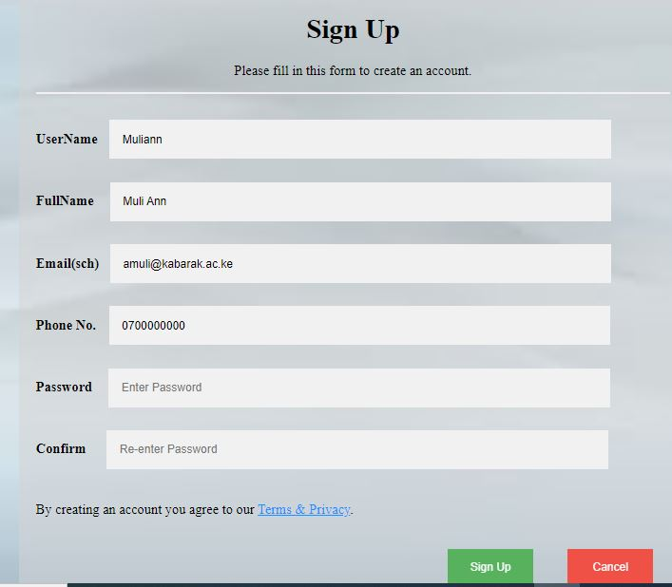

Figure

1. Log in page for different users:

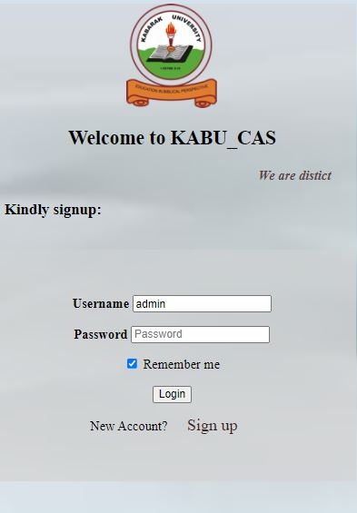

Figure

1. Admin’s landing page

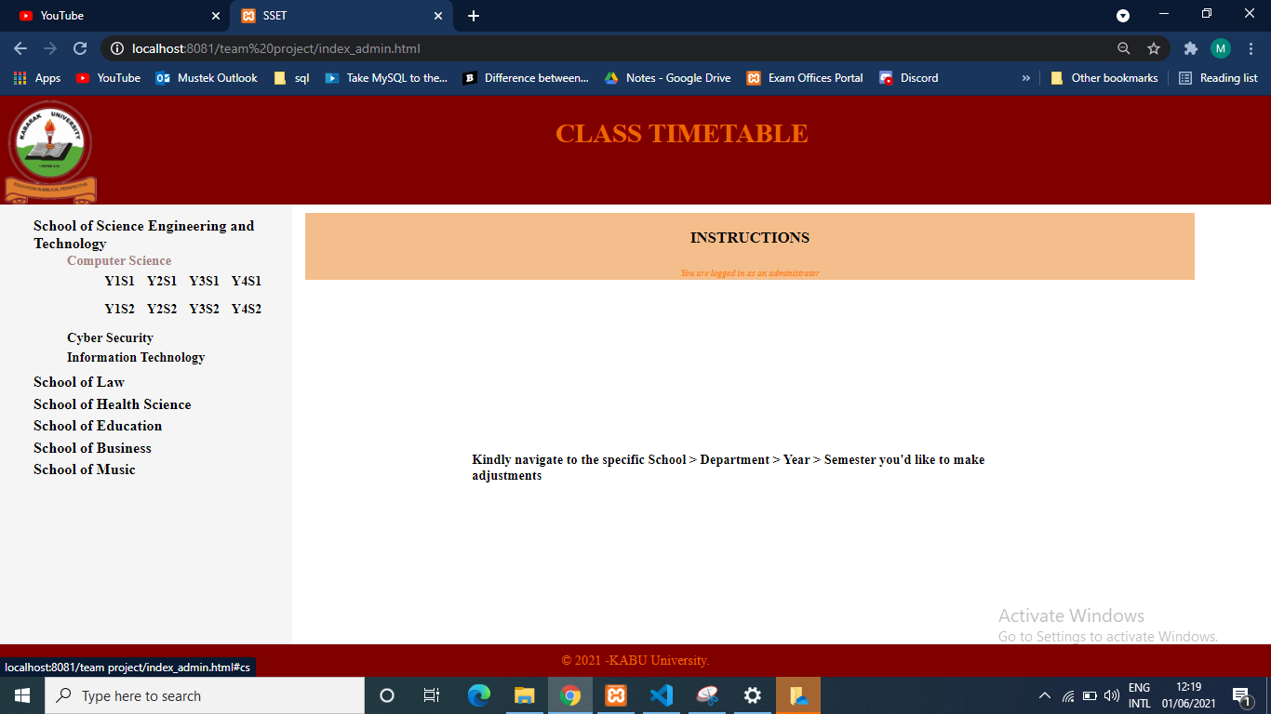

Figure

1. Normal users landing page.

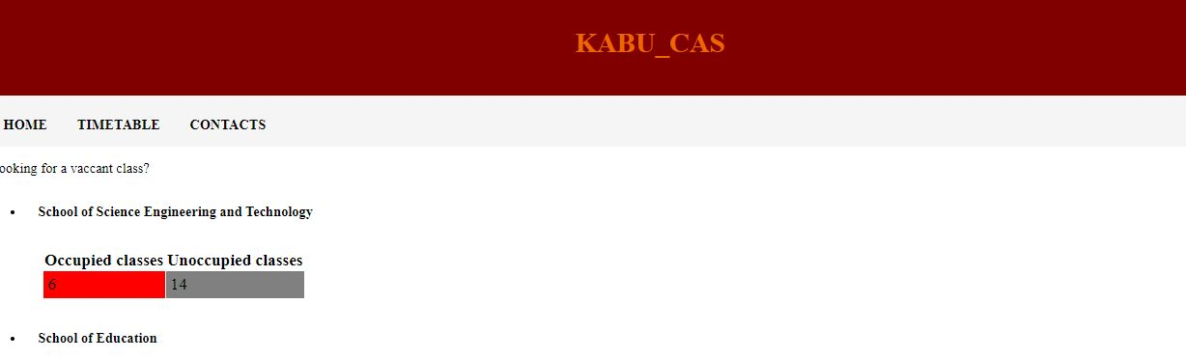

Figure

1. Page for inserting timetables – accessible to admins

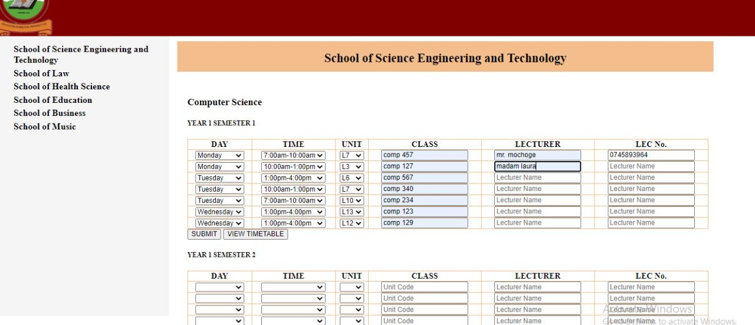

Figure

1. Page for viewing the timetable – accessible to all users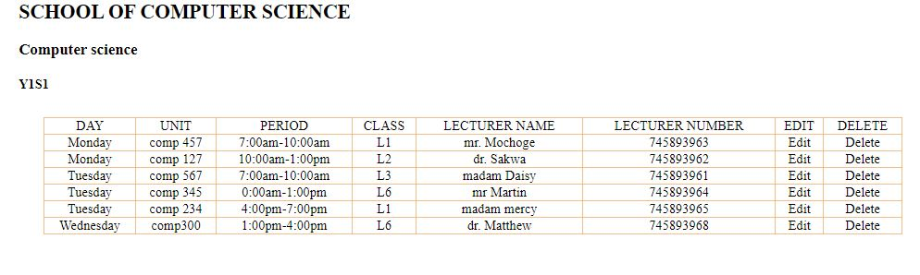

Figure

1. Database tables sample;

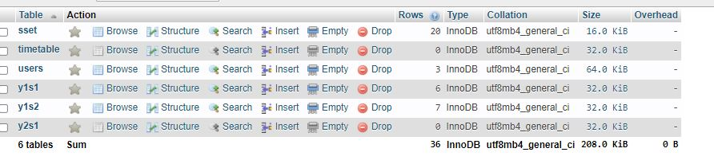

Figure

1. Database timetable sample;

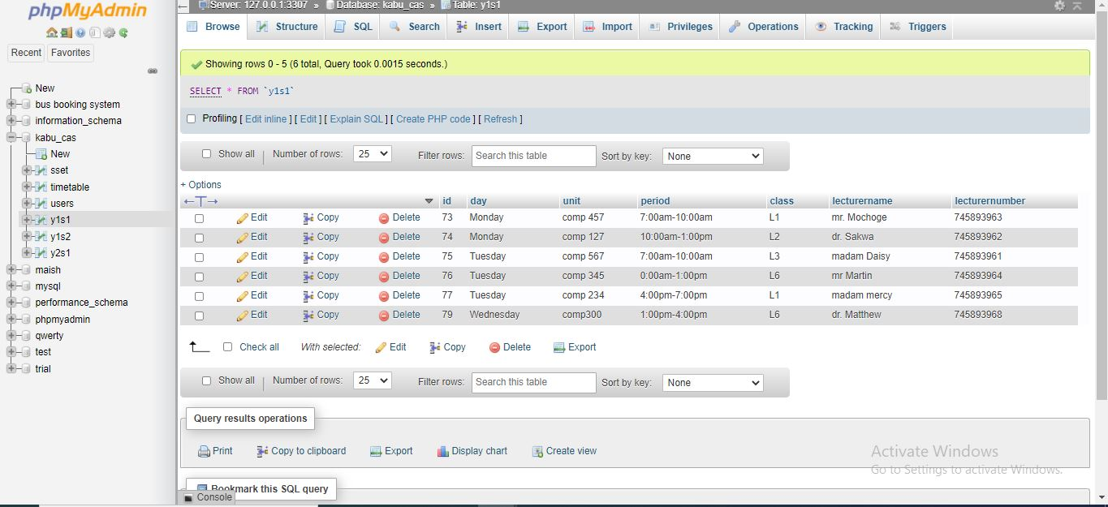

Figure

1. Code samples: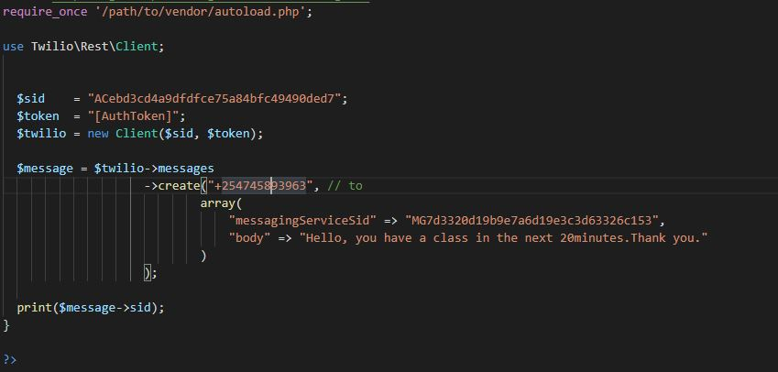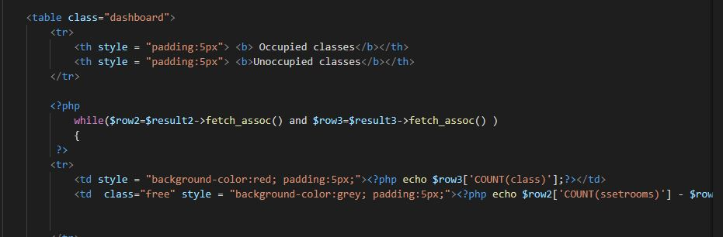

Figure

# CHAPTER 6

# 6.0 RECOMMENDATION

The system is not meant to replace the manual allocation but rather to enable lecture halls to be allocated more accurately. However, with the growing population of the students in the university, there is a need to consider this approach

# 6.1 CONCLUSION

The objectives behind the project were fulfilled though there were different challenges but we acquired experience in facing the different types of problems and brain storming their solutions. In the end, system worked but not to full expectation. In future we hope to work on the system so that the system works well as required in our expectations and objectives.

# REFERENCES

Kabarak University website. https://sites.google.com/a/kabarak.ac.ke/kabarak-university-students-intranet/documents

CLASS ALLOCATION SYSTEM USED BY THE UNIVERSITY OF WESTERN AUSTRALIA**:** [https://www.cas.uwa.edu**.**](https://www.cas.uwa.edu.)(2018).

# APPENDIX

**Part of code (Front-end)**

<html>  
<head>  
  <title>Schools</title>  
  <link rel="stylesheet" href="style.css">  
  <link rel="stylesheet" href="https://stackpath.bootstrapcdn.com/font-awesome/4.7.0/css/font-awesome.min.css">  
  
</head>  
<body>  
  <div class="menu-bar">  
<ul>  
  <li class="hover me"><a href="#"><i class="fa fa-home"></i>Home</a></li>  
  <li><a href="#"><i class="fa fa-calendar"></i>Timetabling office</a>  
  <li><a href="#"><i class="fa fa-graduation-cap"></i>Schools</a>  
     <div class="sub-menu-1">  
       <ul>  
           <li><a href="medicine.html">School of Medicine and Health Sciences</a></li>  
           <li><a href="sset.html">School of Science,Engineering and Technology</a></li>  
           <li class><a href="pharmacy.html">School of Pharmacy</a></li>  
           <li><a href="education.html">School of Education</a></li>  
           <li><a href="business.html">School of Business and Economics</a></li>  
      </ul>  
    </div>  
      </li>  
  <li><a href="#"><i class="fa fa-phone"></i>Contact Us</a>  
    <div class="sub-menu-2">  
    <ul >  
      <li><b>KABARAK</b></li>  
      <li><i>Tel: (254) 0729 223 370</i></li>  
      <li><i>Email: info@kabarak.ac.ke</i></li>  
      <li><b>Complaints/Compliments</b></li>  
      <li><i>feedback@kabarak.ac.ke</i></li>  
      <li><b>Academic Registrar</b></li>  
      <li><i>academic_registrar@kabarak.ac.ke</i></li>  
    </ul>  
  </div>  
  </li>  
  
</ul>  
</div>  
<div class="footer">  
  &copy; <script>document.write(new Date().getFullYear())</script> -KABU University.  
</div>  
</body>  
</html>